LANDIS-II-Site v3.0 User Guide
LANDIS-II Tool

Zaixing Zhou, Brian R. Sturtevant, Brian R. Miranda

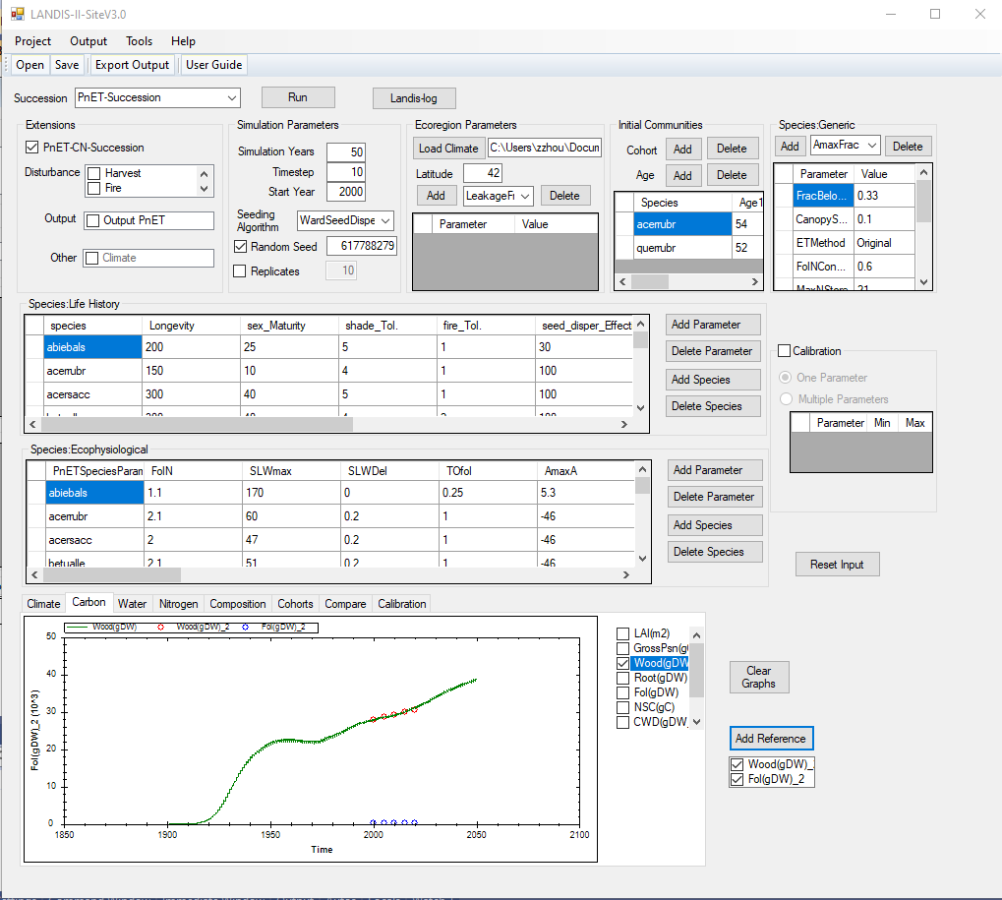

USDA Forest Service, Northern Research Station

Last Revised: April 29, 2026

Table of Contents
1 Introduction 2
1.1 Installation 2
1.2 Major Releases 2
1.2.1 Version 3.0 2
1.3 Minor Releases 2
1.3.1 Version 3.0.1 2
1.4 References 2
1.5 Acknowledgments 2
2 Tool Description 3
2.1 Overview 3
2.2 Structure of the Tool 3
2.3 Graphic User Interface 4
2.3.1 Input Section 5
2.3.1.1 Extensions 5
2.3.1.2 Simulation Parameters 5
2.3.1.3 Ecoregion Parameters 6
2.3.1.4 Initial Communities 6
2.3.1.5 Species: Generic 6
2.3.1.6 Species: Lift History 6
2.3.1.7 Species: Ecophysiological 6
2.3.1.8 Calibration 7
2.3.1.9 Run button 7
2.3.2 Output Section 7
2.3.2.1 Landis-log button 7
2.3.2.2 Output Plotting 7
2.3.2.3 Add Reference 8
2.4 Menu 9
2.4.1 Project 9
2.4.1.1 Save 9
2.4.1.2 Open 9
2.4.1.3 Run 9
2.4.1.4 Exit 9
2.4.2 Output 9
2.4.3 Tools 9
2.4.3.1 Build LANDIS Input Package 9
2.4.3.2 Scenarios 9
2.4.3.3 Landis User Interface 10
2.4.4 Help 10
2.5 Tool Bar 10

Introduction
This document describes the LANDIS-II-Site V3.0 tool for use with the LANDIS-II model. For information about the model and its core concepts, see the LANDIS-II Conceptual Model Description.

Installation
LANDIS-II-Site does not require formal installation; it can be run directly using the executable file (LANDIS-II-SiteV3_0.exe). However, the program requires all of the .dll and .netmodule files from the Zip to be located in the same folder as the executable file when it is run.
To install the tool, unzip the LANDIS-II-SiteV3_0.zip at your local Windows folder to make a folder named LANDIS-II-SiteV3_0. There are three subfolders in the main directory: Input, Inter, and Output.

Major Releases

Version 3.0
The version 3.0 of this tool is a new design, instead of an update of previous version 2.0. Revisions and enhancements of this tool will be denoted by increasing version numbers.

Minor Releases

Version 3.0.1
Coming soon.

References
LANDIS-II Documentation Online:
http://www.landis-ii.org/documentation.
LANDIS-II Biomass Succession v3.2 Extension User Guide:
http://www.landis-ii.org/extensions/biomass-succession
LANDIS-II PnET-Succession Extension User Guide:
https://github.com/LANDIS-II-Foundation/Extension-PnET-Succession/blob/master/deploy/docs/LANDIS-II%20PnET-Succession%20v4.1%20User%20Guide.pdf

Acknowledgments
Coming soon.

Tool Description

Overview
The LANDIS-II-Site V3.0 tool is designed to provide a friendly Windows GUI (graphic user interface) for users to run LANDIS-II on a single site. It is not built on the previous versions in terms of the codes, but a fully new developed version. One of the main goals of the GUI is to exclude all the LANDIS-II science processes and only provide an interface for generating input files for LANDIS-II and its variety of extensions. Thus, the tool does not need to be necessarily updated while LANDIS-II and its extensions are upgraded. To run LANDIS-II on the GUI, the site tool uses the local original LANDIS-II program installed on the computer. The tool can also generate an input package for the local LANDIS-II program and thus users can export it anywhere to run LANDIS-II in its original way. The program allows users to easily experiment with various parameter settings and visualize outputs for the purpose of exploring model behavior, model calibration, model testing, extension comparisons, and training.

Structure of the Tool
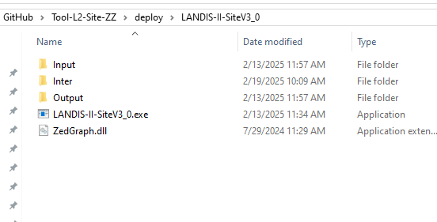
Figure 1. The structure of the LANDIS-II-SiteV3_0
After installation, a local Windows folder named LANDIS-II-SiteV3_0 is created. The model structure is shown similar like Figure 1, which includes at least three subfolders in the main directory: Input, Inter, and Output, the tool executable LANDIS-II-SiteV3_0.exe, and needed dll libraries.
Double click LANDIS-II-SiteV3_0.exe to launch the site tool, shown in Figure 2.

Graphic User Interface
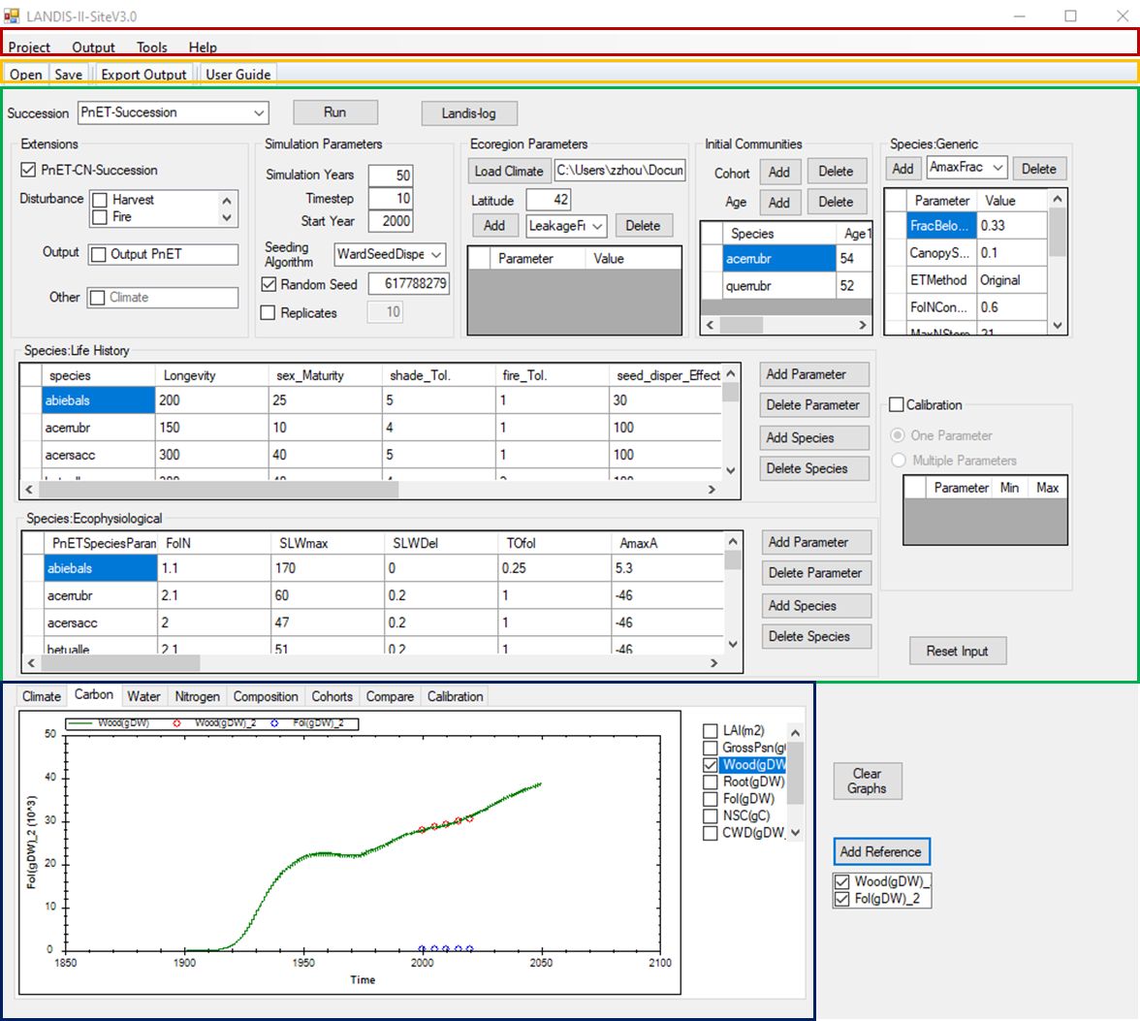
Figure 2. The graphic user interface (GUI) of the LANDIS-II-SiteV3_0. It primarily includes the menu (red box) and tool strips (orange box), the input section (green box), and the output graph section (blue box).
The GUI includes three major sections: the menu and tool strips, the input section, and the output graph section. The menu (red box) includes commands to build and save projects, to import output results, tools for further/depth processing the data, and helpful resources. The tool strip (orange box) contains short-cut buttons from the menu. The green section includes all input parameters from the users to run the program. The blue section is the graphing of the output results.

Input Section
To run the program for a case, users need to build a project and define all necessary input parameters in the input section (Fig 2, green box). After the program starts, a default project is loaded to fill the input section. The input consists of several sub-sections: extensions, general simulation parameters, ecoregion parameters, initial communities, and three level of species parameters (generic for all species, life history traits and ecophysiological traits for individual species).

Extensions
Users first select one of succession extensions, e.g., PnET-Sucession. The GUI will accordingly change a little based on the selected succession extension. Several disturbance/other extensions are optional to link with the succession extension. Please note that the user needs to refer to the selected succession extension for parameters not defined here.

Simulation Parameters
This section contains basic parameters to run the case.
Simulation Years: the length of time the simulations should be run.
Start Year: the year when the simulation starts.
Timestep: the time interval between attempts to establish. Succession runs growth calculations at an annual timestep, but establishment years are controlled by the input Timestep.
Seeding algorithm: options for the seeding algorithm.
Random Seed: The tool will automatically record in the text box the random number seed that was applied during the last execution of the tool. To control the random number seed, check the Random Number Seed check box. Whenever the checkbox is checked, the tool will use the number provided in the text box as the random number seed. Multiple runs with the same random number seed will have identical results even when stochastic processes are running (e.g., establishment probabilities). Users can synchronize simulations across multiple computers by using the same random number seeds.
Replicates: A batch mode that runs multiple replicates using the same input values can be turned on by checking the check box. When batch mode is selected, the user can specify how many replicates to run by entering the number in the text box. All of the replicates will be averaged and graphed on the graphing section. When replicate is used, the simulation uses automatic random seeds by default.

Ecoregion Parameters
This section contains ecoregional parameters.
Load Climate: Click the button to allocate the climate file in the computer. The path of the climate file is shown in the following text box. The user can also directly paste the path to the text box.
Latitude: The latitude of the simulated site in decimal.
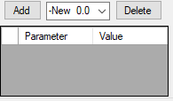 | A table for additional ecoregional parameters. The dropbox provides all default parameters along with their values. The user can Add existing parameters to the table for modification or add a new parameter and define it in the table. Delete button can delete the selected parameter in the table.

Initial Communities
This section contains initial communities defined by the users. A cohort is an age group of a species. To add a new species or an age, click the Add button associated with Species and Age. The user can modify all data in the community table. Click the Delete button to delete the selected species or age.

Species: Generic
This section contains the generic species parameters, which apply to all species in the simulation. The dropbox provides all default parameters along with their values. The user can Add existing parameters to the table for modification or add a new parameter and define it in the table. Delete button can delete the selected parameter in the table.

Species: Lift History
This section contains the life traits for each species. To add a new species or a parameter, click the Add button associated with species and parameter. The user can modify all data in the associated table. Click the Delete button to delete the selected species or parameter.

Species: Ecophysiological
This section contains the ecophysiological traits for each species. To add a new species or a parameter, click the Add button associated with species and parameter. The user can modify all data in the associated table. Click the Delete button to delete the selected species or parameter.

Calibration
The calibration function provides users with a way to easily experiment with various parameter settings and visualize outputs for the purpose of exploring model behavior, model calibration, model testing, extension comparisons, and training. Check the checkbox, two calibration methods are activated, one parameter or multiple parameters.
The One-parameter approach allows the user to change one parameter at a time and compare the results. To make comparison of two simulations, the user first unchecks the Calibration and runs the model with the input as a control. Then, check the Calibration and adjust the parameter interested. Run the model again as the calibrated results. The output graph Calibration tab will show the control and calibrated results for different variables.
The Multiple-parameter approach allows the user to change several parameters at a time and set a range for each parameter. The tool generates five points for each parameter and makes combinations for all parameters. The program then runs for each combination and shows the results from different scenarios in the output graph Calibration tab.

Run button
Click the Run button to run the model. A message box appears to indicate whether the run is complete successfully or not.

Output Section

Landis-log button
Users can view the LANDIS-II log file by clicking the Landis-log button.

Output Plotting
After a successful run, the output section (Fig 2, blue box) can graph simulation results grouped by Climate, Carbon, Water, Nitrogen, Composition, Cohorts, Compare and Calibration. On each graph tab, there is a graph and a list of variables. Check the variable to show its figure or uncheck the variable to clear its figure. Note the variable lists will change in accordance with the selected succession extension.
The Carbon, Water, Nitrogen, Composition, and Compare tabs show the site level results, and the Cohorts tab shows the results of different cohorts. The Calibration tab shows the comparison of calibration function at the site level.
The Composition tab shows the species composition over time based on the relative mass of each species.
The Cohorts tab shows the results for all cohorts. Select a cohort and then a variable, the figure of the variable of the cohort will show on the graph.
The Compare tab shows all results at the site level. The user can use it to compare different variables across different result groups, e.g., the relationship between climate and carbon fluxes.
If the calibration function is unchecked, the Calibration tab will show the control results.
Click the Clear Graphs button to clear all existing graphs.

Add Reference
The Add Reference allows the user to load an observation file (CSV) for comparison. The reference file is a csv file with some format requirements.
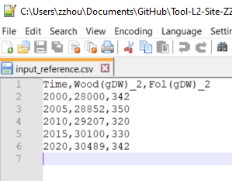
Figure 3 The structure of reference file
The first column of reference file has to be “Time” with the observation years as values. The second and next columns of reference file are observed variables. There is no limitation on the number of observed variables. However, each variable name is followed by a “_” plus a number, e.g., 2,3,4. 2 represents carbon variable, 3 water variables, and 4 nitrogen. These variables are shown in the list box below the Add Reference button. Toggle them to graph the observations in their specific graph tab to compare the simulated results.

Menu

Project
After the input parameters are filled, the user has built a project.

Save
Click Save in the Project menu to save the input parameters as csv file.

Open
The user can open an existing project to replace all values in the GUI by clicking the Open button in the Project menu.

Run
Click Run to run the program for the project.

Exit
Click Exit to quit the program.

Output
The Export Output in the Output menu can export all output files to a different path.

Tools
The Tools menu includes a few useful utility tools for the program.

Build LANDIS Input Package
Click this button to generate all input files for LANDIS to run in its official way. The package normally includes a site_run.bat file. Click it to run LANDIS for the project in its official way.

Scenarios
Click this button to run the program for a scenario file which can include multiple sites. It is designed to run multiple sites at the same time. All scenario results is located in the Ouput/ Output_Sce folder.

Landis User Interface
Click this button to run a program called Landis User Interface, which is tool to explore, edit, run, and show the simulation of PnET-Succession extension. Please refer to its user guide for more details.

Help
The Help menu includes a User Guide for this tool.

Tool Bar
The tool bar contains some menu commands for users to quickly access.
Open: Open an existing project file (csv).
Save: Save current input as a project file (csv).
Run: Run the program.
Export Output: Export the modeled output to another location.
User Guide: Open the user guide.

